Introduction:

The data are all published monthly by U.S. government. It is aimed to analyze whether there are some differences for three categories’ energy prices (electricity, gas, utility) between west coast cities and east coast cities because of geographical location. Three cities are summarized, which are Los Angeles, San Francisco and Seattle.

LA Electricity Trend Abnormal

A close up of a map

Description generated with very high confidence

Generally, energy prices will have a slight rise for each year. However, after comparisons with three categories for each year, the abnormal trend in Los Angeles is shown. Electricity price in 2017 is 13% lower than the price in last year and keep it stable till the year end.

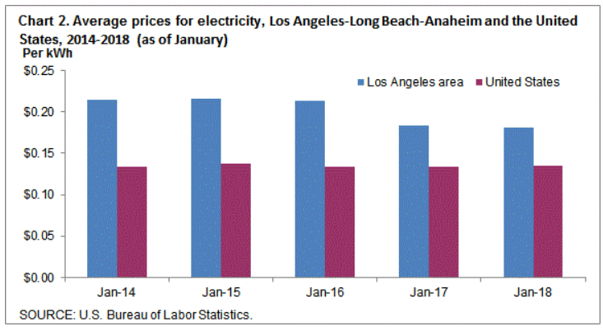

One of the reasonable reason is that electricity prices kept at a much higher level from 2014 to 2016 compared with the U.S. average electricity price. Hence, it is an appropriate timing to decrease this city’s price to an acceptable level.

Second, the Los Angeles Government opposed more fossil fuel plants in public and encouraged to introduce renewable solar energy. Even more ambitiously, it was proposed legislation to require 100% of the state’s power to come from renewable energy sources by 2045. The favorable news will stimulate price fluctuation.

Average Price Comparison

A close up of a map

Description generated with very high confidence

Circle sizes represent the prices level. Small is for lower price and Big is for higher price. From the dashboard above, we could conclude that energy prices’ of Seattle are lower than other two cities’ with corresponding lower living cost.